The Emphysema Severity Index: Representing CT Abnormalities in a Multidimensional COPD Framework
Peter J. Castaldi¹,²; Matteo Paoletti³; Mariaelena Occhipinti⁴; Alessandra Sorano³; Federico Lavorini³; Enrico Maiorino¹; Craig P. Hersh¹,⁵; Edwin K. Silverman¹,⁵; Massimo Pistolesi³

¹ Channing Division of Network Medicine, Brigham and Women's Hospital, Boston, MA, USA
² Division of General Internal Medicine and Primary Care, Brigham and Women's Hospital, Boston, MA, USA
³ Department of Experimental and Clinical Medicine, University of Florence, Florence, Italy
⁴ Division of Radiology, Fondazione Toscana Gabriele Monasterio, Pisa, Italy
⁵ Division of Pulmonary and Critical Care Medicine, Brigham and Women's Hospital, Boston, MA, USA

Key words: Chronic Obstructive Pulmonary Disease; Spirometry; Pulmonary Emphysema; Computed Tomography; Respiratory Function Tests

ABSTRACT
Rationale: Spirometry remains central to the diagnosis of chronic obstructive pulmonary disease (COPD), but airflow obstruction alone does not capture the structural and clinical heterogeneity of the disease. A recently proposed multidimensional diagnostic framework integrating spirometry, chest computed tomography (CT)-defined structural abnormalities, and respiratory symptoms improved disease characterization and prognostic assessment.
Objectives: To determine whether the CT-defined structural component of this multidimensional COPD framework can be represented by the Emphysema Severity Index (ESI), a spirometry-derived measure based on expiratory flow-volume curve morphology.
Methods: Using the COPDGene cohort, we represented the CT-defined structural component of the original framework with ESI, while preserving airflow obstruction and symptom criteria. Agreement between CT-based and ESI-based classifications and their associations with mortality, exacerbations, and longitudinal lung function decline were evaluated.
Measurements and Main Results: The ESI-based framework reproduced the CT-based framework with 91% agreement (κ=0.82), 88% sensitivity, and 94% specificity. Both classifications showed highly comparable associations with all-cause mortality, respiratory mortality, and prospective exacerbations, whereas differences in longitudinal FEV₁ decline were modest with both frameworks. Concordant classification identified participants at highest clinical risk, whereas discordant groups showed intermediate risk profiles. Secondary analyses showed that ESI identified smokers with preserved spirometry at increased risk of subsequent FEV₁ decline.
Conclusions: An ESI-based spirometric representation of CT-defined structural abnormalities preserved the diagnostic and prognostic information of a multidimensional COPD framework. Information derived from expiratory flow-volume curve morphology may enable broader implementation of multidimensional COPD assessment without requiring CT imaging.

INTRODUCTION
Chronic obstructive pulmonary disease (COPD) is a multidimensional disease in which airflow limitation, structural lung abnormalities, and respiratory symptoms provide complementary information on disease expression (1–6). Consequently, reliance on spirometry alone incompletely captures the biological heterogeneity of COPD and has prompted the development of diagnostic approaches integrating multiple disease dimensions (7–10).
Recently, Bhatt and colleagues proposed a multidimensional diagnostic framework integrating spirometry, chest computed tomography (CT), and symptom burden (11). By combining airflow obstruction with respiratory symptoms and imaging evidence of emphysema or airway wall thickening, this framework identifies clinically relevant COPD beyond conventional spirometric criteria and improves prediction of mortality and lung function decline. The framework, which we refer to as the MD-COPD (multidimensional COPD) classification, was subsequently validated in an independent population (12). However, the requirement for chest CT may constrain implementation of this otherwise attractive diagnostic approach in routine clinical practice, large epidemiological studies, and healthcare settings where advanced imaging is unavailable or impractical.
Chest CT has substantially advanced the understanding of COPD heterogeneity by providing direct information on structural lung abnormalities, yet its cost, radiation exposure, and limited availability constrain its widespread use. Consequently, a physiological descriptor capable of representing the structural dimension of COPD could substantially broaden the applicability of multidimensional disease assessment.
The Emphysema Severity Index (ESI) is a continuous spirometric measure derived exclusively from the morphology of the expiratory flow-volume curve (13, 14). Unlike conventional spirometric indices, which quantify expiratory volumes or flows and require comparison with reference populations, ESI is calculated from absolute spirometric measurements and is intrinsically independent of ethnic and anthropometric reference equations. Previous studies have demonstrated close associations between ESI and quantitative CT measures of emphysema, together with independent prognostic value across different populations (15, 16). These observations suggest that ESI may provide a spirometry-derived representation of the structural information contributed by chest CT within a multidimensional diagnostic framework.
We therefore evaluated whether the structural contribution of chest CT within the MD-COPD framework (11) could be represented using ESI, thereby enabling a broader implementation while preserving diagnostic agreement and prognostic performance. Using the COPDGene cohort, we compared the agreement of an ESI-based classification with the original CT-based classification, and we compared the predictive value of both classifications across mortality, respiratory exacerbations, and longitudinal lung function decline.
METHODS
Study design
The study was designed to determine whether the CT-derived structural component of the MD-COPD framework (11) could be represented by a measure obtained from standard spirometry. To isolate this contribution, only the structural component of the original framework was reformulated using the Emphysema Severity Index (ESI), whereas spirometric airflow obstruction and symptom criteria were unchanged. The resulting ESI-based classification was compared with the original CT-based framework for diagnostic agreement and prognostic performance.
Study population
The analysis was performed using data from the COPDGene study (NCT00608764), a multicenter observational cohort of current and former smokers aged 45–80 years with a smoking history of at least 10 pack-years. Baseline evaluation included standardized pre- and post-bronchodilator spirometry, chest CT imaging, symptom assessment, and longitudinal clinical follow-up. Participants with complete data required to construct both CT-based and ESI-based classifications were included. Individuals with pre-existing diagnosed interstitial lung disease or bronchiectasis were not analyzed. Details of COPDGene design, imaging protocols, and follow-up have been previously reported (17). Briefly, quantitative emphysema was measured as low attenuation area below −950 Hounsfield units (LAA-950) using Thirona software. CT visual emphysema and airway wall thickness were scored according to Fleischner Society criteria (18, 19), and visual emphysema was deemed to be present for scores of 1 or greater (where 1 = Mild emphysema). Visually assessed airway wall thickening was deemed to be present for a visual score of 2, corresponding to Definite wall thickening.
Original MD-COPD diagnostic framework
The MD-COPD framework (11) integrates three domains: spirometric airflow obstruction, respiratory symptoms, and CT-defined structural abnormalities. The major diagnostic criterion is post-bronchodilator FEV₁/FVC below 0.70. Five minor criteria comprise two structural criteria, visual emphysema (Fleischner assessment at least mild) and airway wall thickening (Fleischner assessment definite) (18), together with three symptom criteria: modified Medical Research Council (mMRC) dyspnea score of 2 or greater, St. George’s Respiratory Questionnaire (SGRQ) total score of 25 or greater, and chronic bronchitis. Participants meeting the major criterion together with at least one minor criterion are classified as COPD-major; participants meeting at least three of five minor criteria without the major criterion are classified as COPD-minor; participants meeting the major criterion alone are classified as Airflow Limitation (AFL)-only-noCOPD; and the remaining participants are classified as noCOPD.
ESI-based spirometric representation of the structural component
The CT-defined structural component was represented using ESI while preserving all other components of the original multidimensional framework. ESI was calculated from absolute values of standard spirometric measurements, including peak expiratory flow (PEF), forced vital capacity (FVC), and forced expiratory flows (FEF) measured after expiration of 25%, 50%, and 75% of FVC (FEF25%, FEF50%, and FEF75%), using a previously validated algorithm (13, 14). ESI ranges from 0 to 10 and reflects expiratory flow-volume curve morphology independently of ethnic and anthropometric reference equations.
ESI thresholds reproducing the CT-derived structural classification were identified using a single-variable classification tree (rpart) in a randomly selected training cohort (80% of participants) and evaluated in the remaining testing cohort (20%). The final thresholds were determined based on tradeoffs between sensitivity and specificity with some rounding of the final numbers for ease of interpretability. These were subsequently applied to the entire study population. To preserve the original diagnostic architecture, in which the structural domain contributes up to two of five minor criteria, the ESI-based representation was implemented as a two-threshold scoring rule: ESI values below the lower threshold (ESI < 1) contribute zero minor criteria; values from the lower threshold up to but not including the upper threshold (1 ≤ ESI < 2.5) contribute one; values at or above the upper threshold (ESI ≥ 2.5) contribute two. Complete threshold selection results are reported in Supplemental Table 1.
Diagnostic subgroup definitions
Participants were classified according to both the original CT-based framework and the ESI-based framework. Agreement and discordance between classifications were evaluated by defining four groups: Both-COPD, CT-only-COPD, ESI-only-COPD, and Both-noCOPD. For analyses examining the relationship between spirometric measures and structural lung abnormalities, participants were also stratified by smoking and spirometric status: never smokers, Preserved Ratio Impaired Spirometry (PRISm), Global Initiative for Chronic Obstructive Lung Disease (GOLD) stages 1-4, and subjects with preserved lung function (FEV1 % predicted >80% and FEV1/FVC>0.7) were referred to as GOLD 0 subjects.
Clinical outcomes and statistical analysis
Clinical outcomes included all-cause mortality, cause-specific mortality, prospective exacerbation rate, and longitudinal decline in FEV₁. Mortality, exacerbations, and repeated spirometric measurements were analyzed using available COPDGene follow-up data. Overall mortality was determined through longitudinal follow-up calls combined with Social Security Death Index searches (COPDGene dataset: COPDGene_VitalStatus_SM_NS_Sep23.csv). Cause-specific mortality was determined by a pre-specified adjudication process using a modified version of the Towards a Revolution in COPD Health (TORCH) criteria as previously described (20) (COPDGene dataset: COPDGene_Mort_COD_Adj.csv). Respiratory exacerbations were analyzed from the COPDGene Longitudinal Followup (LFU) program dataset (COPDGene dataset: LFU_SidLevel_Comorbid_SM_30SEP21.txt). Longitudinal FEV1 decline was obtained from the main COPD phenotype file containing data from the first three study visits spanning a ~15-year follow-up period (COPDGene_P1P2P3_SM_NS_Long_Sep24.csv).
Classification agreement between CT-based and ESI-based frameworks was assessed using sensitivity, specificity, overall agreement, and Cohen’s κ coefficient. Associations between ESI and quantitative CT measures of emphysema (%LAA−950HU (21) and parametric response mapping [PRM] emphysema (22)) were evaluated using Pearson correlation coefficients.
Associations with clinical outcomes were assessed using Cox proportional hazards models (hazard ratio, HR) for mortality, negative binomial regression models (incidence-rate ratio, IRR) for exacerbations, and linear mixed effects models (random intercept per participant) for longitudinal FEV₁ decline. Three adjustment sets were used. For mortality and exacerbation models, covariates were age, sex, race, current smoking status, pack-years, and body mass index (BMI). For the FEV₁ decline models, baseline height replaced BMI as the anthropometric adjustment (age, sex, race, current smoking status, and pack-years retained). GOLD stratified analyses, including the continuous ESI models, omitted BMI because of collinearity between low BMI and severe COPD. Pre-specified sensitivity analyses were (i) exclusion of participants with ESI = 10, (ii) an alternative four-criterion framework replacing only the emphysema criterion, and (iii) restriction to severe exacerbations. All analyses were performed in R (version 4.5.2).
We tested equivalence between the CT-based and ESI-based frameworks at two complementary levels. At the discrimination level, we compared the C-index between frameworks for each mortality outcome (23); equivalence was defined a priori as a between-framework C-index difference within ±0.02 and was tested using two one-sided tests (TOST) (24). At the per-category effect-size level, we used a paired subject resample bootstrap (B = 1,000) and refit all category models (Cox proportional hazards for mortality; negative binomial with follow-up-year offset for exacerbations) under both frameworks. The two-sided p-value reported in Table 1 is the percentile p for the resample distribution of the log effect difference (log HR or log IRR, CT − ESI); values reported as “<0.002” denote iterations in which no resample crossed zero (below the 1/500 resolution of a two-sided percentile test). These p-values are reported to two decimal places because the percentile p is itself a Monte Carlo estimate: at B = 1,000 its standard error is approximately 0.01, so further digits would not be reproducible across runs. Full per-category ΔlogHR and ΔlogIRR estimates with 95% percentile intervals are reported in Supplemental Table 2.
For pairwise between-subgroup comparisons in Table 2, contrasts on the logHR (mortality) and logIRR (exacerbations) scales among the three COPD-positive cross-classification subgroups (Both-COPD, CT-only-COPD, ESI-only-COPD) were derived from the fitted Cox and negative binomial models and reported with single-step adjusted p-values from the multcomp package. Full contrast estimates are reported in Supplemental Table 3.

RESULTS

Study population and relationship between ESI and structural lung abnormalities
The analytic cohort comprised 9,402 COPDGene participants with complete baseline data on all diagnostic criteria of the multidimensional framework (Supplemental Table 4). The cohort spanned the full COPDGene spectrum, including 106 never-smokers, 4,054 smokers without airflow obstruction (GOLD 0), 1,129 participants with PRISm, and 4,113 participants with GOLD 1–4 airflow obstruction. Mean baseline ESI increased monotonically with severity across the spectrum, from 0.83 in never-smokers to 8.30 in GOLD 4 participants.
Across the entire cohort, ESI showed significant associations with quantitative CT measures of emphysema, including the percentage of low attenuation area below −950 Hounsfield units (%LAA−950HU; r=0.78) and PRM-defined emphysema (r=0.81). The strength of these relationships varied according to disease severity, with weak correlations observed in groups with minimal structural abnormalities (GOLD 0, r=0.08) and stronger relationships among participants with established airflow obstruction (GOLD 3, r=0.58; Supplemental Table 5).

Agreement between CT-based and ESI-based multidimensional classifications
The ESI-based framework showed high agreement with the original CT-based classification (Figure 1), agreeing in more than nine out of ten participants (91%; κ=0.82), with 88% sensitivity and 94% specificity.
Within the preserved spirometry subgroup (COPD-minor pathway), analysis of discordant classifications demonstrated distinct clinical and structural profiles (Figure 2). CT-only-COPD participants showed a higher prevalence of visually assessed emphysema, although groups did not have significant differences in CT quantitative emphysema. In contrast, ESI-only-COPD participants showed higher ESI values. Interestingly, while the ESI-only group had no visual emphysema, it had nominally higher levels of quantitative emphysema than the CT-only group.

Prognostic performance of the ESI-based multidimensional framework
The original CT-based and ESI-based multidimensional classifications yielded comparable associations with mortality and prospective exacerbations (Table 1). Across outcomes, adjusted HRs and IRRs for COPD-minor and COPD-major categories were similar between the two frameworks, although for the COPD-major group the CT-based classification did have a significantly higher HR for all-cause mortality and higher IRR for exacerbations. There was no significant difference between the two classifications for the COPD-minor groups. Under both frameworks, the AFL-only-noCOPD category was not significantly associated with increased risk across evaluated outcomes, consistent with its classification outside the multidimensional COPD categories.
Longitudinal FEV₁ decline demonstrated less distinct differences across diagnostic categories than mortality and exacerbation outcomes. Under both frameworks, differences in FEV₁ decline for COPD-minor and COPD-major were modest and not statistically significant after adjustment. The only significant difference in FEV₁ was that AFL-only-noCOPD was associated with an increase in FEV₁ relative to the noCOPD group in the ESI-based but not the CT-based classification (10.1 ml/yr, p=0.02; Supplemental Table 9).
Discrimination was nearly identical between frameworks, with comparable C-index values for all-cause and respiratory mortality (Supplemental Table 10). Pre-specified sensitivity analyses yielded consistent findings (Supplemental Tables 11, 12, and 13), and comparable results between CT-based and ESI-based classifications were observed across cause-specific mortality analyses, including cardiovascular, cancer-related, and other causes of death (Supplemental Tables 6, 7, and 8).

Outcomes of concordant and discordant classifications
Within the preserved-spirometry subgroup, cross-classification analyses showed graded differences in clinical outcomes among participants classified according to agreement or disagreement between the CT-based and ESI-based frameworks (Table 2).
Compared with participants classified as noCOPD by both frameworks, Both-COPD participants showed increased all-cause mortality, respiratory mortality, and exacerbation risk. Discordantly classified groups showed intermediate clinical risk profiles: CT-only-COPD participants showed increased mortality and exacerbation risk, whereas ESI-only-COPD participants showed higher point estimates for respiratory mortality and exacerbations, although estimates were less precise because of the smaller sample size.

Secondary analyses of continuous ESI
In secondary analyses evaluating ESI as a continuous measure, ESI provided prognostic information beyond FEV₁/FVC for selected outcomes (Supplemental Tables 14 and 15). Among GOLD 0 smokers, higher baseline ESI was associated with accelerated subsequent lung function decline, with each 1-unit increase predicting an additional 4.73 mL/year decline in FEV₁ (P=0.001) independent of baseline FEV₁/FVC. Although GOLD 0 and PRISm participants showed similar baseline ESI values, PRISm participants demonstrated greater longitudinal increases in ESI over follow-up (Supplemental Table 16). ESI was essentially unaffected by acute bronchodilator response, with a mean change between pre- and post-bronchodilator measurements of only −0.09 (Supplemental Table 17).

DISCUSSION
In this study, we evaluated a reformulation of the recently proposed Bhatt et al. MD-COPD diagnostic framework by using a spirometric descriptor derived from the expiratory flow-volume curve in place of its CT-defined structural component. The main finding was that representing visually assessed CT structural abnormalities using the Emphysema Severity Index (ESI) preserved the overall diagnostic architecture of the original framework and generated a classification with comparable prognostic associations. The ESI-based reformulation demonstrated high agreement with the CT-based classification and maintained similar relationships with mortality, respiratory outcomes, and exacerbation risk. These findings suggest that an ESI-based spirometric representation can provide clinically meaningful information in place of the CT structural criteria required by the MD-COPD classification.
CT and spirometry interrogate different aspects of the disease process. Chest CT directly visualizes structural abnormalities, including parenchymal destruction and airway changes (18), whereas ESI reflects the integrated physiological consequences of these abnormalities on expiratory flow generation. Loss of elastic recoil, small airway dysfunction, and heterogeneous regional abnormalities may all contribute to alterations in the shape of the expiratory flow-volume curve (25–27). Thus, imaging and spirometry represent different measurement domains that may capture complementary manifestations of the same underlying biological process. The objective of this spirometric representation is therefore not to reproduce CT morphology, but to capture the functional consequences of structural abnormalities that determine clinical expression and prognosis.
Another distinctive feature of ESI is its independence from acute bronchodilator response. In the present cohort, ESI was essentially unchanged after bronchodilation (mean ΔESI=−0.09 across n=10,160 paired pre/post-bronchodilator measurements from all COPDGene participants with valid paired spirometry rather than from the analytic cohort; Supplemental Table 17), extending previous observations reported in a small COPD population (28). This stability suggests that spirometric curve morphology captures mechanical properties of the respiratory system that are not substantially influenced by reversible changes in airway caliber. This characteristic may be clinically relevant because bronchodilator responsiveness in COPD is variable over time and may introduce uncertainty when used to define stable disease characteristics (29).
The relationship observed between ESI and quantitative CT measures of emphysema further supports the concept that structural imaging and spirometric measures provide related but non-identical information. Associations were weak among individuals with minimal structural abnormalities, where limited biological variability reduces the expected relationship between imaging and spirometric measures, but were substantially stronger among participants with moderate to severe airflow obstruction and structural disease. Therefore, imperfect correlation between CT and ESI should not necessarily be interpreted as disagreement, but rather as evidence that anatomical and spirometric measurements capture overlapping but distinct dimensions of COPD.
The analysis of discordant classifications further illustrates this concept. Participants classified as COPD by the original CT-based framework frequently showed visually detected emphysema despite quantitative CT emphysema values within the normal range (30). This pattern reflects the ability of visual CT assessment to identify early or mild morphological abnormalities not captured by quantitative emphysema burden. Because the original framework assigns a structural criterion for even mild visually identified emphysema (11), quantitatively normal participants can still meet the CT-based structural component regardless of whether they are ultimately classified as Both-COPD or as CT-only-COPD; the observation is a general property of the visual CT criterion rather than a phenomenon unique to the discordant subgroup. Conversely, participants classified only by the ESI-based framework showed abnormalities in expiratory flow-volume curve morphology and a high symptom burden despite not meeting the visually assessed CT structural criteria. These discordant patterns should therefore not simply be viewed as false positive or false negative classifications, but as examples of the different biological information provided by structural imaging and spirometric assessment.
Cross-classification analyses demonstrated that discordance between frameworks was associated with clinically relevant information. Participants classified as COPD by both approaches carried the greatest risk, whereas discordant groups displayed intermediate risk profiles. These findings suggest that agreement between imaging and spirometric representations identifies individuals with the strongest disease expression, while discordance may identify different manifestations within the COPD spectrum.
An additional observation supporting the multidimensional concept was the behavior of participants with airflow limitation alone. Participants classified as AFL-only-noCOPD did not demonstrate significantly increased risk of mortality or exacerbations under either the CT-based or ESI-based framework. This observation supports the concept that multidimensional COPD classification may improve diagnostic specificity by distinguishing isolated airflow limitation from broader disease expression characterized by structural, spirometric, or symptomatic abnormalities.
Two secondary analyses treating ESI as a continuous variable provide insight into the contribution of flow-volume curve morphology to early disease detection. Among smokers with preserved spirometry (formerly GOLD 0), higher baseline ESI predicted steeper subsequent FEV₁ decline independently of baseline FEV₁/FVC. Thus, ESI may identify smokers at increased risk of lung-function decline before conventional COPD spirometric criteria are met, potentially relevant to individuals with normal spirometry but early smoking-related lung disease (31–34). Conversely, after inclusion of FEV₁/FVC, continuous ESI added little to prediction of future exacerbations (IRR=1.01, p=0.727), suggesting that its contribution within categorical MD-COPD is captured primarily by the thresholds defining the structural criterion rather than by per-unit variation. PRISm participants also showed greater longitudinal increases in ESI than GOLD 0 participants despite similar baseline values, suggesting that flow-volume curve morphology may track disease processes not captured by a single conventional spirometric classification.
Beyond preserving the diagnostic and prognostic performance of the CT-based framework, the present findings have important practical implications. Because spirometry is inexpensive and more widely available than chest CT, ESI-based multidimensional COPD assessment can be more readily applied in routine clinical practice, primary care, epidemiological studies, and clinical trials. Rather than replacing CT, this approach provides a practical strategy for extending multidimensional COPD assessment to settings in which structural imaging cannot be routinely incorporated.
This study has several limitations. Although the ESI-based framework preserved the diagnostic and prognostic performance of the multidimensional classification, no single physiological descriptor can be expected to capture every aspect of CT-defined structural abnormalities. The threshold values used to represent the CT-defined structural component were derived within the COPDGene cohort and require prospective validation in independent populations. The present study was designed to reproduce the MD-COPD framework and therefore compared ESI with the visually assessed CT structural criteria used in that framework rather than with quantitative CT phenotyping approaches. The ESI-only-COPD (n=94) and AFL-only-noCOPD (n=170) subgroups are small; the associated confidence intervals are correspondingly wide and do not exclude modest clinically meaningful risks, so quantitative comparisons involving these subgroups should be interpreted cautiously. Finally, although the secondary analyses suggest potential applications of ESI for identifying smokers at increased risk of disease progression, these findings require prospective confirmation.

CONCLUSIONS
In conclusion, a spirometric descriptor derived from expiratory flow-volume curve morphology preserved the contribution of the structural domain within a multidimensional COPD diagnostic framework while maintaining comparable prognostic associations. These findings support the concept that imaging-based and spirometry-derived descriptors can provide complementary representations of COPD and may enable broader implementation of multidimensional disease assessment.

REFERENCES
1. Burrows B, Fletcher CM, Heard BE, Jones NL, Wootliff JS. The emphysematous and bronchial types of chronic airways obstruction: a clinicopathological study of patients in London and Chicago. Lancet 1966;1:830–835.
2. Snider GL. Chronic obstructive pulmonary disease: a definition and implications of structural determinants of airflow obstruction for epidemiology. Am Rev Respir Dis 1989;140:S3–S8.
3. Agusti A, Calverley PM, Celli B, et al. Characterisation of COPD heterogeneity in the ECLIPSE cohort. Respir Res 2010;11:122.
4. Camiciottoli G, Bigazzi F, Paoletti P, et al. Pulmonary function and sputum characteristics predict computed tomography phenotype and severity of COPD. Eur Respir J 2013;42:626–635.
5. Castaldi PJ, Xu Z, Young K, et al. Heterogeneity and progression of chronic obstructive pulmonary disease: emphysema-predominant and non-emphysema-predominant disease. Am J Epidemiol 2023;192:1647–1658.
6. Bhatt SP, Silverman EK, Crapo JD. Beyond spirometry in COPD: expanding the diagnostic paradigm. ERJ Open Res 2026;12:00045-2026. doi: 10.1183/23120541.00045-2026.
7. Celli BR, Cote CG, Marin JM, et al. The body-mass index, airflow obstruction, dyspnea, and exercise capacity index in chronic obstructive pulmonary disease. N Engl J Med 2004;350:1005-1012.
8. Lowe KE, Regan EA, Anzueto A, et al. COPDGene 2019: redefining the diagnosis of chronic obstructive pulmonary disease. Chronic Obstr Pulm Dis 2019;6:384-399.
9. Stolz D, Mkorombindo T, Schumann DM, et al. Towards the elimination of chronic obstructive pulmonary disease: a Lancet Commission. Lancet 2022;400:921-972.
10. Morelli T, Geeves ME, Mohammed A, et al. Beyond spirometry: understanding COPD origins to support a new diagnostic approach. ERJ Open Res 2026;12:00885-2025.
11. Bhatt SP, Abadi E, Anzueto A, et al. A multidimensional diagnostic approach for chronic obstructive pulmonary disease. JAMA 2025;333:2164-2175.
12. Wu F, Huang S, Zhou K, et al. Clinical validation of a multidimensional diagnostic approach for COPD in Chinese individuals. Chest 2026;169:371-384.
13. Occhipinti M, Paoletti M, Bartholmai BJ, et al. Spirometric assessment of emphysema presence and severity as measured by quantitative CT and CT-based radiomics in COPD. Respir Res 2019;20:101.
14. Occhipinti M, Paoletti M, Crapo JD, et al. Validation of a method to assess emphysema severity by spirometry in the COPDGene study. Respir Res 2020;21:103.
15. Luoto J, Pihlsgård M, Pistolesi M, et al. Emphysema severity index (ESI) associated with respiratory death in a large Swedish general population. Respir Med 2022;200:106899.
16. Maio S, Viegi G, Carrozzi L, et al. Emphysema Severity Index (ESI): a new spirometric parameter in epidemiology. ERJ Open Res 2026: in press. doi:10.1183/23120541.01587-2025.
17. Regan EA, Hokanson JE, Murphy JR, et al. Genetic epidemiology of COPD (COPDGene) study design. COPD 2010;7:32–43.
18. Lynch DA, Austin JH, Hogg JC, et al. CT-definable subtypes of chronic obstructive pulmonary disease: a statement of the Fleischner Society. Radiology 2015;277:192–205.

19. Lynch DA, Moore CM, Wilson C, et al. CT-based visual classification of emphysema: association with mortality in the COPDGene Study. Radiology 2018;288:859–866.

20. Young KA, Regan EA, Han MK, et al. Subtypes of COPD have unique distributions and differential risk of mortality. Chronic Obstr Pulm Dis 2019;6:400-413.
21. Schroeder JD, McKenzie AS, Zach JA, et al. Relationships between airflow obstruction and quantitative CT measurements of emphysema, air trapping, and airways in subjects with and without chronic obstructive pulmonary disease. AJR Am J Roentgenol 2013;201:W460–W470.
22. Galbán CJ, Han MK, Boes JL, et al. Computed tomography-based biomarker provides unique signature for diagnosis of COPD phenotypes and disease progression. Nat Med 2012;18:1711–1715.
23. Harrell FE Jr, Lee KL, Mark DB. Multivariable prognostic models: issues in developing models, evaluating assumptions and adequacy, and measuring and reducing errors. Stat Med 1996;15:361-387.
24. Schuirmann DJ. A comparison of the two one-sided tests procedure and the power approach for assessing the equivalence of average bioavailability. J Pharmacokinet Biopharm. 1987;15(6):657-680.
25. Macklem PT, Mead J. Resistance of central and peripheral airways measured by a retrograde catheter. J Appl Physiol 1967;22:395-401.
26. Saltzman HP, Ciulla EM, Kuperman AS. The spirographic "kink": a sign of emphysema. Chest 1976;69:51-55.
27. Pellegrino R, Crimi C, Gobbi A, et al. Severity grading of chronic obstructive pulmonary disease: the confounding effect of phenotype and thoracic gas compression. J Appl Physiol 2015;118:796-802.
28. Dal Negro RW, Turco P, Povero M, Pistolesi M. Basal computation of Emphysema Severity Index (ESI) in COPD patients is not affected by bronchodilation. EC Pulmon Respir Med 2024;14:01-09.
29. Albert P, Agusti A, Edwards L, et al. Bronchodilator responsiveness as a phenotypic characteristic of established chronic obstructive pulmonary disease. Thorax 2012;67:701-708.
30. Hoffman EA, Ahmed FS, Baumhauer H, et al. Variation in the percent emphysema-like in a healthy, nonsmoking multiethnic sample. Ann Am Thorac Soc 2014;11:898-907.
31. Regan EA, Lynch DA, Curran-Everett D, et al. Clinical and radiologic disease in smokers with normal spirometry. JAMA Intern Med 2015;175:1539-1549.
32. Woodruff PG, Barr RG, Bleecker E, et al. Clinical significance of symptoms in smokers with preserved pulmonary function. N Engl J Med 2016;374:1811-1821.
33. Fortis S, Strand M, Bhatt SP, et al. Respiratory exacerbations and lung function decline in people with smoking history and normal spirometry. Am J Respir Crit Care Med 2025;211:957-965.
34. Abdo M, Reck M, Stiebeler S, et al. Clinically relevant change in airway wall thickness to identify disease activity in COPD and smokers at risk. Eur Respir J 2026;67:2900306.

FIGURES
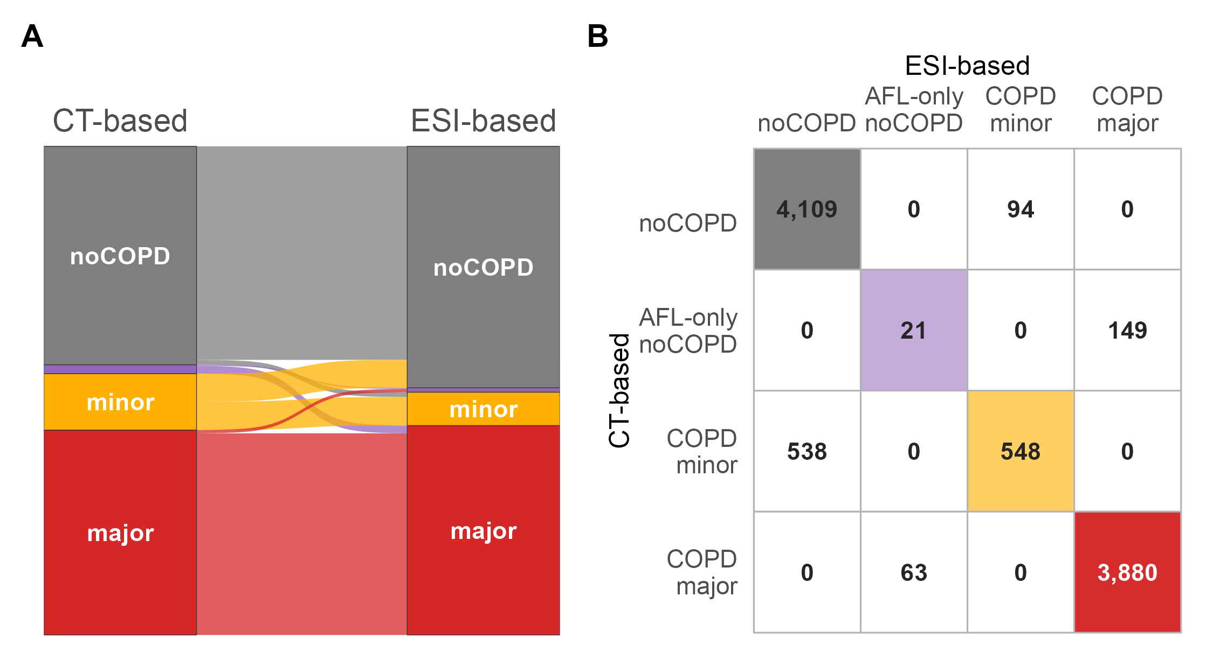
Figure 1. Concordance between the CT-based and ESI-based multidimensional-framework diagnostic categories. (A) Alluvial plot of participant flow between the four MD-COPD categories under the CT-based (left axis) and ESI-based (right axis) framework. Stratum block heights and ribbon widths are proportional to participant counts; ribbons are colored by CT-based origin so that a reader can trace where each CT-based category is reclassified under the ESI-based framework. (B) Cross-classification matrix of the same 9,402 participants (CT-based rows × ESI-based columns). Diagonal cells (concordant) are colored using the same Panel-A category palette; off-diagonal cells (discordant) are shown as white cells with the participant count and a light border. Cell opacity on the diagonal is proportional to count so that large concordant groups are visually dominant. Overall agreement between the two frameworks is 91% (κ = 0.82), with sensitivity 88% and specificity 94% for the ESI-based framework relative to the CT-based reference. Abbreviations: ESI, Emphysema Severity Index; CT, computed tomography; AFL, airflow limitation; κ, Cohen's kappa coefficient.
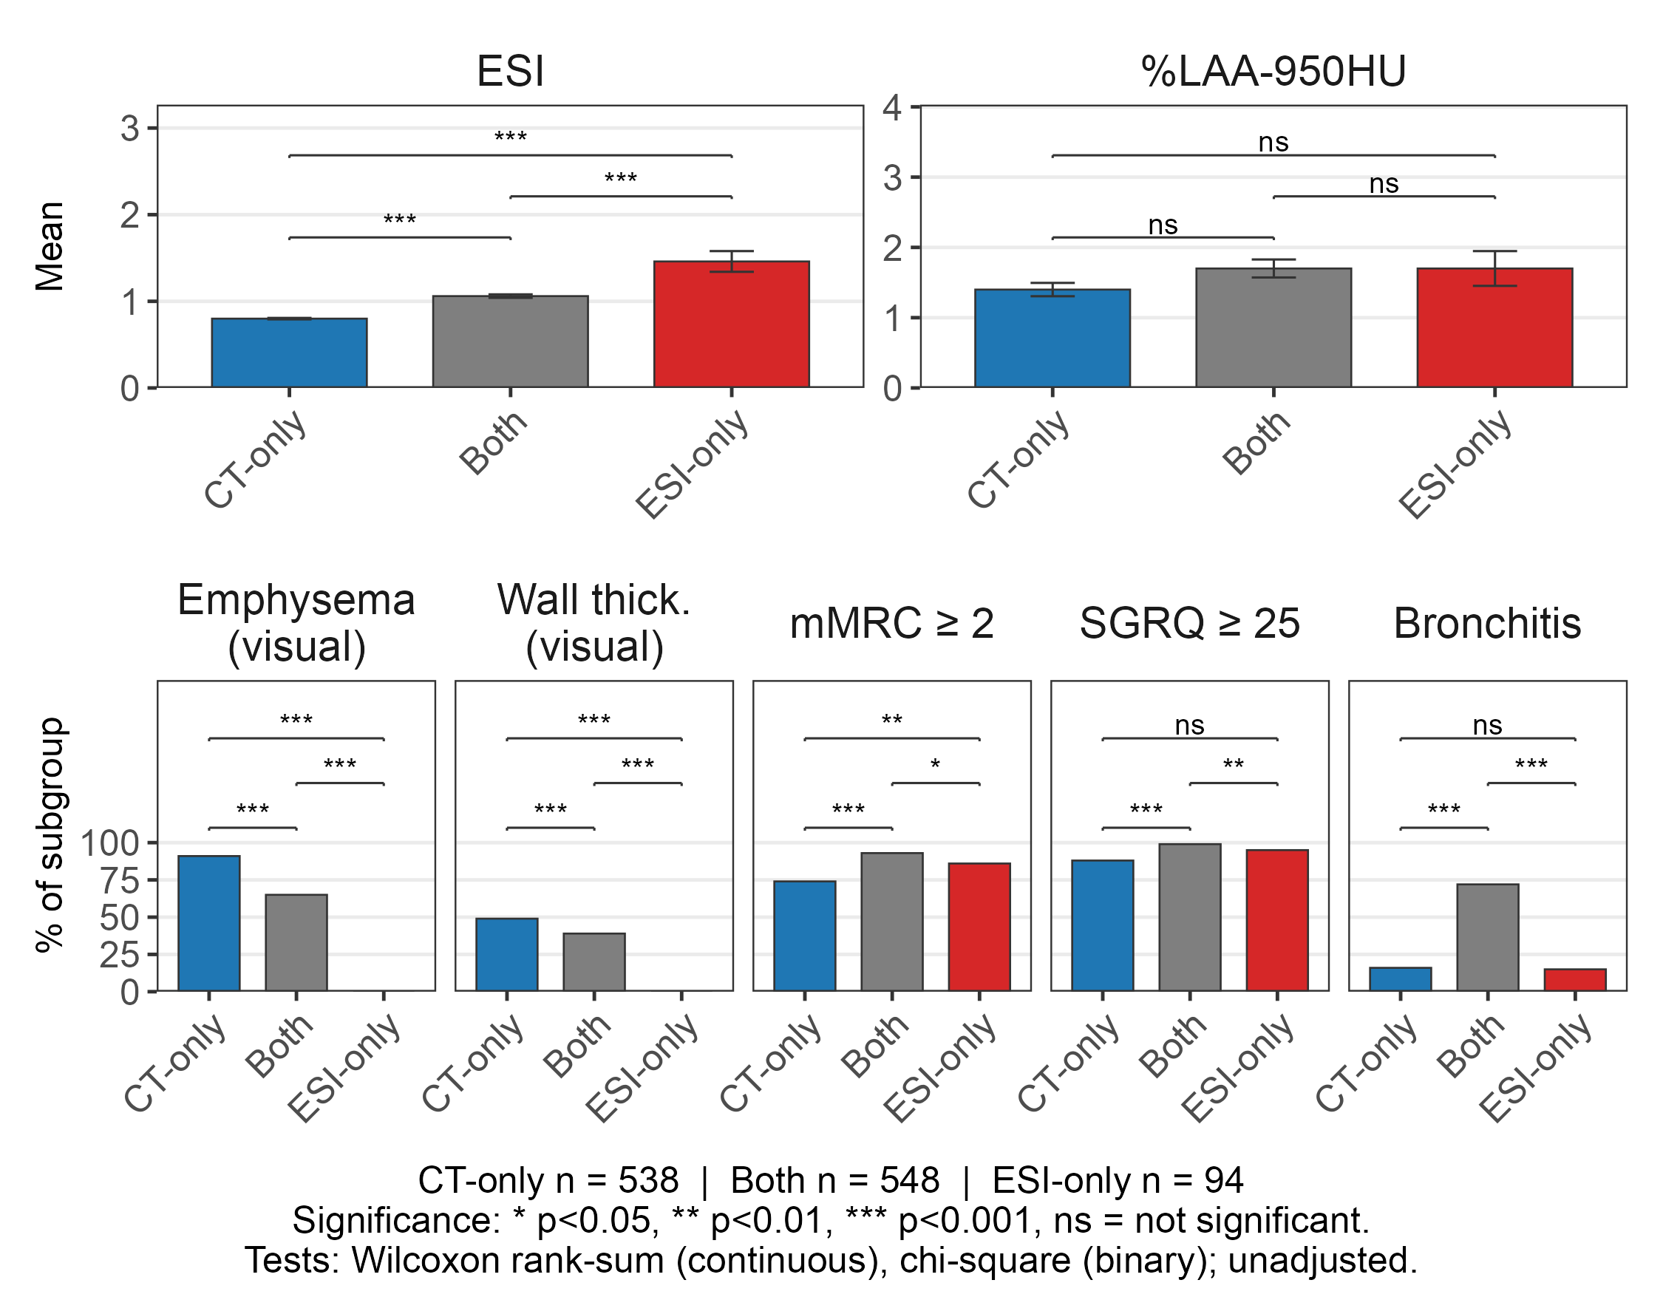
Figure 2. Clinical, physiological, and imaging characteristics of participants classified concordantly or discordantly by the CT-based and ESI-based multidimensional frameworks, restricted to the preserved spirometry (COPD-minor pathway) subgroup. Three cross-classification subgroups within the preserved spirometry stratum are compared: CT-only-COPD, Both-COPD, and ESI-only-COPD. Top row panels show subgroup means (ESI, %LAA-950HU) with standard error bars. Bottom row panels show the percentage of subgroup participants meeting each dichotomous criterion (visually assessed emphysema, visually assessed airway wall thickening, mMRC ≥ 2, SGRQ total ≥ 25, chronic bronchitis). Abbreviations: CT, computed tomography; ESI, Emphysema Severity Index; %LAA-950HU, percentage of low attenuation lung area below −950 Hounsfield units; mMRC, modified Medical Research Council dyspnea scale; SGRQ, St. George's Respiratory Questionnaire.

TABLES
Outcome (metric) | Category | CT-based (95% CI) | ESI-based (95% CI) | CT vs ESI (p)
All-cause mortality (HR) | COPD-minor | 1.91 (1.64–2.22) | 1.94 (1.63–2.32) | 0.85
All-cause mortality (HR) | COPD-major | 2.59 (2.35–2.86) | 2.39 (2.18–2.63) | <0.002
Respiratory mortality (HR) | COPD-minor | 4.80 (2.14–10.76) | 5.68 (2.43–13.32) | 0.70
Respiratory mortality (HR) | COPD-major | 36.27 (20.85–63.07) | 30.95 (18.76–51.06) | 0.29
Exacerbations (IRR) | COPD-minor | 2.72 (2.36–3.14) | 2.77 (2.33–3.30) | 0.80
Exacerbations (IRR) | COPD-major | 5.05 (4.59–5.56) | 4.47 (4.07–4.90) | <0.002
Table 1. Associations of MD-COPD diagnostic categories with mortality and exacerbation outcomes under the CT-based and ESI-based frameworks. Cox proportional hazards (mortality) and negative binomial (exacerbations) models estimate the hazard ratio (HR) or incidence-rate ratio (IRR) for each MD-COPD category relative to the noCOPD reference. Adjustment covariates are age, sex, race, current smoking status, pack-years, and body mass index; 95% confidence intervals are shown. The CT vs ESI column reports a two-sided p-value for the difference in effect estimate between the CT-based and ESI-based framework fits for the same category (see Methods). Per category effect difference details are reported in Supplemental Table 2. The AFL-only-noCOPD category was omitted from this display because it was not significantly associated with any of the three outcomes. Abbreviations: CT, computed tomography; ESI, Emphysema Severity Index; HR, hazard ratio; IRR, incidence-rate ratio; CI, confidence interval; BMI, body mass index; AFL, airflow limitation; COPD, chronic obstructive pulmonary disease.

Classification group | All-cause mortality HR (95% CI) | Respiratory mortality HR (95% CI) | Exacerbation IRR (95% CI)
Both-noCOPD | Reference | Reference | Reference
CT-only-COPD | 1.53 (1.25–1.88)ᵃ | 2.90 (0.91–9.28)ᵃ | 2.00 (1.60–2.51)ᵃ
ESI-only-COPD | 1.26 (0.76–2.07)ᵃ | 4.86 (0.62–38.02)ᵃ | 1.62 (0.97–2.68)ᵃ
Both-COPD | 2.02 (1.66–2.46)ᵃ | 6.10 (2.19–16.96)ᵃ | 3.15 (2.52–3.93)ᵇ
Table 2. Mortality and exacerbation outcomes across the four cross-classification groups defined by CT-based and ESI-based COPD status. Analyses are restricted to the preserved-spirometry (COPD-minor pathway) subgroup, as in Figure 2. Within that subgroup, participants are cross-classified by whether they meet the COPD definition under each framework, yielding four mutually exclusive groups: Both-noCOPD (reference), CT-only-COPD (CT-based only), ESI-only-COPD (ESI-based only), and Both-COPD. Cox proportional hazards models estimate the hazard ratio (HR) for all-cause and respiratory mortality; a negative binomial model estimates the incidence-rate ratio (IRR) for exacerbations. Adjustment covariates are age, sex, race, current smoking status, pack-years, and body mass index. The mortality models were fit on 5,289 participants and the exacerbation model on 4,635. Superscript letters after each estimate encode pairwise significance among the three COPD positive subgroups within each outcome column: within an outcome, groups sharing a letter did not differ significantly (single step adjusted Wald contrasts, multcomp; α = 0.05); groups not sharing any letter differed significantly. Thus, the only significant difference was the Both-COPD group’s exacerbation IRR, which was significantly higher than both the CT-only (p=0.005) and ESI-only groups (p=0.037). Full pairwise contrast estimates are reported in Supplemental Table 3. Abbreviations: CT, computed tomography; ESI, Emphysema Severity Index; COPD, chronic obstructive pulmonary disease; HR, hazard ratio; IRR, incidence-rate ratio; CI, confidence interval; BMI, body mass index.

